S-100 – Part 5

Feature Catalogue
Summary of Substantive Changes in Edition 5.2.0

Change Summary | Clauses Effected
Part 5 – Feature Catalogue
Corrected Figure 5-A-1 and Table 5-A-16, and added new Table 5-A-21, to allow for the capability to define the display visibility level of attributes in end user systems. | Appendix 5-A
Corrected multiplicity for Class S100_FC_FeatureAssociation, Role subType from [0..] to [0..*]. | Appendix 5-A, Table 5-A-10

Contents

5-1 Scope 1
5-2 Conformance 1
5-3 Normative References 1
5-4 Principal Requirements 2
5-4.1 Feature Catalogue 2
5-4.2 Information Elements 2
5-4.2.1 Introduction 2
5-4.2.2 Named Types 2
5-4.2.3 Properties 5
5-4.2.4 Feature Associations 5
5-4.2.5 Bindings 5
5-4.2.6 Definitions and source references 7
5-4.2.7 Completeness 8
Appendix 5-A – Feature Catalogue Model (normative) 9

Page intentionally left blank

Scope
This Part provides a standard framework for organizing and reporting the classification of real world phenomena in a set of geographic data. It defines the methodology for classification of the feature types and specifies how they are organized in a Feature Catalogue and presented to the users of a set of geographic data. This methodology is applicable to creating catalogues of feature types in previously uncatalogued domains and to revising existing Feature Catalogues to comply with standard practice. It applies to the cataloguing of feature types that are represented in digital form. Its principles can be extended to the cataloguing of other forms of geographic data.
A Feature Catalogue shall be defined for each Product Specification.
This Part is applicable to the definition of geographic features at the type level but not applicable to the representation of individual instances of each type.

Conformance
This profile conforms to conformance class 2 of ISO 19106:2004. The following is a brief description of the specializations and generalizations where the profile differs from ISO 19110.
- New abstract classes, S100_FC_Item, S100_FC_NamedType, and S100_FC_ObjectType are introduced.
- A new class, S100_FC_InformationType is introduced.
- New classes, S100_FC_FeatureBinding, S100_FC_InformationBinding and S100_FC_AttributeBinding are introduced.
- A new class, S100_CD_AttributeConstraints is introduced.
- The class FC_FeatureAttribute is specialized to be the abstract class S100_FC_Attribute.
- New classes, S100_FC_SimpleAttribute and S100_FC_ComplexAttribute are introduced.
- The classes FC_InheritanceRelation, FC_FeatureOperation, FC_Binding, FC_Constraint and FC_BoundFeatureAttribute are not used.
Further reference or explanation of the above changes can be found in the following text where appropriate.

Normative References
The following referenced documents are required for the application of this document. For dated references, only the edition cited applies. For undated references, the latest edition of the referenced document (including amendments) applies.
ISO 19110:2005, Geographic Information – Methodology for feature cataloguing

Principal Requirements

Feature Catalogue
An S-100 based Feature Catalogue presents the abstraction of reality represented in one or more sets of geographic data as a defined classification of phenomena. The basic level of classification in the Feature Catalogue is the feature type. Features and attributes are bound in a Feature Catalogue. The definitions of features and attributes are drawn from a Feature Concept Dictionary. A Feature Catalogue shall be available in electronic form (for example XML) for any set of geographic data that contains features. A Feature Catalogue may also comply with the specifications of this component of S-100 independently of any existing set of geographic data.

Information Elements

Introduction
The following clauses specify general and specific requirements for Feature Catalogue information elements. A Feature Catalogue generally consists of a list of named types, a list of properties for named types and the information on how both are linked together. Furthermore it contains a list of sources for its definitions. The model is primarily based on the ISO 19110 standard but there are both extensions and differences in this model.
There are two major extensions to the feature types: information types and complex attributes. To achieve a greater flexibility in modelling the data within a data set it is necessary to define complex structures of information. Both extensions allow the creation of those structures. Whereas complex attributes define complex characteristics for one named type, information types can be shared.
Unlike feature types, which are an abstraction of real world phenomena, information types are just shareable structured pieces of information. In a geographic data set they will be associated to feature types or to other information types. Both types: feature and information, have many common characteristics. This is accommodated by deriving both types from a common abstract base class: the named type.
Complex attributes are an aggregation of other attributes which may be either simple or complex.
The arrangement of content may be different depending on format, for example printed document, XML, hypertext etc.

Named Types

Common Characteristics
Feature and information types are inherited (see clause 5-4.2.2.2 below) from the abstract class S100_FC_NamedType. This class describes all common characteristics, for example, the name and the definition of the corresponding type. Furthermore a code has to be defined for the type. This code will later be used to identify an instance of a named type in a geographic data set. If the definition is taken from a Feature Concept Dictionary that reference is also given.
Feature and information types can be derived from other feature or information types. This includes the possibility that some types are abstract, meaning no instances of such types can be in a data set. Named types can be characterized by attributes and additional information may be available by information types that are related to them. The former is defined by attribute bindings whereas the latter is achieved by information bindings.

Inheritance
In data modelling, inheritance is a way to form new types using types that have already been defined. The new types, known as derived types (or sub-types), take over (or inherit) properties of the pre-existing types, which are referred to as base types (or super-types). The derived types may define new additional properties, but also change existing properties, the latter is called overriding. This is used to assign unique property values to sub-types such as name and definition but overriding of characteristics such as bindings to attributes should be avoided by only including common characteristics in the super-type. In the scope of a Feature Catalogue both feature and information types can be derived from other feature or information types. But a feature type cannot be derived from an information type or vice versa. Attributes and associations defined for the super-type will also belong to the sub-type. The definition of the sub-type is usually redefined. In the context of this standard inheritance will be always simple, meaning each type cannot be derived from more than one super-type.
EXAMPLE 1 Cardinal and lateral buoys may be derived from an (abstract) type buoy. The super-type already defines attributes like colour, shape, name, and associations to lights or top marks. The derived types add special information only valid for the specialized type like category of cardinal mark or category of lateral mark respectively.
Inheritance builds hierarchical structures which may become difficult to manage if they are too complex or not sufficiently mature. It is generally good design practice to keep the depth of an inheritance tree as shallow as possible. On the other hand, sometimes inheritance trees simplify models by grouping types which are derived from the same basic concept and which have the same characteristics, so inheritance even at multiple levels should be used where appropriate.
Inheritance relationships between types in a Feature Catalogue generally correspond to inheritance relationships in the Application Schema. Determinations of when to use inheritance and to what degree and level are information modelling questions and should be addressed by Application Schema designers and project teams taking into consideration factors such as Application Schema and Feature Catalogue complexity, maintenance, application requirements, etc.
EXAMPLE 2 In the information model for the ENC Product Specification, all geographic feature types have information bindings to the information type SupplementaryInformation and feature bindings to the cartographic feature TextAssociation. Defining a common super-type for all geographic features would allow these two bindings to be made to the super-type instead of repeating them in every geographic feature type.
EXAMPLE 3: In an Application Schema for an “Aids to Navigation” Product Specification, classes defining different types of beacons have many of the same attributes. Also, classes defining different types of buoys share the same characteristics. Super-types GenericBuoy and GenericBeacon are therefore defined. Further, buoys and beacons can all act as structure objects, and there are also other features which can also play the role of structure objects, so another super-type is introduced for generic structure features. AidsToNavigation, StructureObject, GenericBuoy, and GenericBeacon are all abstract classes. The Structure/Equipment association is made between the classes Structure and Equipment and applies to all sub-types of these classes, for example any CardinalBuoy can fill the parent role in a Structure/Equipment association with any sub-type of Equipment.
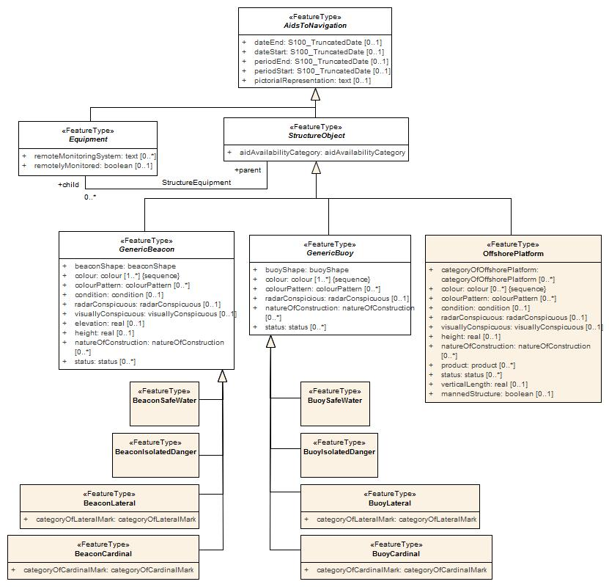
Figure 5-1 – Inheritance Example
        - Considerations for Product Specifications (Informative)
In general the need for inheritance increases with increasing numbers of concepts which can be grouped under a higher-level concept, or as more characteristics are shared between similar types, or even if several different types share some characteristics.
The advantage of excluding inheritance from Feature Catalogues is mainly structural simplification (and consequently simpler processing) since abstract types and inheritance hierarchies need not be implemented; also in S-100-based Product Specifications, inherited enumerated attributes can have different lists of allowed values for different sub-types. The disadvantages include (probable) increases in the volume of the Feature Catalogue especially if many features or information types have common attributes or associations, and increased complexity for maintenance (an update to an attribute nominally bound to a super-type would have to be made to each sub-type at all levels, and this would have to be checked before the Feature Catalogue is released). Also, inheritance is a common paradigm in object-oriented programming and may not be a significant issue for implementations.

Feature Types
Feature types are the basic level of classification in the Feature Catalogue. In addition to the common characteristics they define a feature use type to categorize them. Feature types may be associated to other feature types through feature associations. This will be defined by feature bindings which specify the association as well as the role used for the relationship to the other feature type.

Information Types
Information types are complex pieces of information in a data set that can be shared between many other feature or information types. In regards to their structure, they can also be seen as feature types without a geometric property which have a structure similar to feature types and are categorized as a separate item type.

Properties

Common Characteristics
Properties for feature and information types are attributes and association roles although the latter only applies to feature types. The common characteristics include name, definition, remarks etc. A reference to a Feature Concept Dictionary may be defined.

Attributes
Attributes carry the characteristics of feature and information types. Unlike information types they cannot be shared between different instances. That is, an instance of an attribute belongs to one and only one feature or information type. In this standard there are two different kinds of attributes: simple and complex. Simple attributes carry the value itself, and complex attributes are aggregations of other attributes to achieve a complex and hierarchical data structure.

Simple Attributes
Simple attributes are designed to carry a value. In the Feature Catalogue the domain of the value shall be specified. All attribute values are value types. Part 2a-4.2.9 contains the full list of value types and their definitions. If the value type is an enumeration, or a codelist of type “open enumeration”, a list of ‘Listed Values’ will be defined. For codelists of type open or closed dictionary, a URI identifying a “dictionary” (or “vocabulary”) will be provided as a definition.
Furthermore the value domain can be constrained by the following:
- The length of the text;
- A format specification for structured text;
- A numeric range.
Details are in Appendix 5-A.

Complex Attributes
Complex attributes are aggregations of other attributes that are either simple or complex. The aggregation is defined by means of attribute bindings.

Association Roles
An association role describes the nature of the relationship from one feature type to another feature type in a feature association. In this standard each association has exactly two roles. Either or both may be a default. The documentation of Application Schemas must specify the rule used for default names. Different rules for default names may apply to different associations in the same Application Schema, but each role shall have an unambiguous name, be it an explicit role name or a default role name.

Feature Associations
Feature associations describe the relationships between feature types. Feature associations have a name, definition, remarks, code etc. Each association uses two roles that define the directed use of the relationship. Either or both of the roles may be a default as described in Part 3.
EXAMPLE 1 Structure – Equipment is an example of an association with two roles.
EXAMPLE 2 theAuthority – theContactDetails is an example of an association between classes Authority and ContactDetails which uses two default roles.

Bindings

Attribute Bindings
The following use cases for attribute bindings exist:
- Defining the attribute for feature types;
- Defining the attributes for information types;
- Defining the attributes for feature associations;
- Defining the attributes for information associations;
- Defining the aggregation of attributes for a complex attribute.
The binding specifies the target attribute and the Multiplicity of the attribute. The Multiplicity indicates how many instances of an attribute can be used. Bindings are used to define whether an attribute is mandatory (1..n) or optional (0..n). If the Multiplicity allows more than one instance of an attribute a Boolean flag indicates if the sequence of attributes has a meaning.
If the attribute is a simple attribute with a data type of Enumeration, a list of permitted values can be specified. An empty list indicates that all values defined for the attribute in the Feature Catalogue are valid.

Feature Bindings
The feature binding describes the association between two feature types. Each feature binding is contained within the type definition for a “source” feature type in the Feature Catalogue, and describes the relation of a feature type (the “target”) to the source feature type. A feature binding specifies:
- the name of the feature association;
- the target feature type;
- the role of the target feature type in relation to the source feature (the “role” is the name of the association end at the target);
- the type of association end at the target (ordinary association, aggregation, or composition); and
- the multiplicity of the target feature type.
EXAMPLE: The TrafficSeparationScheme feature type is associated to the TrafficSeparationSchemeLanePart feature by the TrafficSeparationSchemeAggregation association. This association is an aggregation and is depicted in the Figure 5-2 UML diagram below:
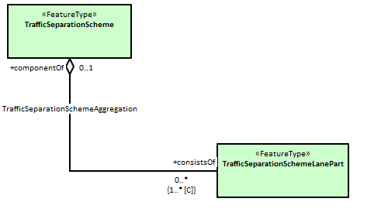
Figure 5-2 – TrafficSeparationSchemeAggregation association between TrafficSeparationScheme and TrafficSeparationSchemeLanePart feature classes
In accordance with UML conventions, the diamond at the TrafficSeparationScheme end means that TrafficSeparationScheme is the “whole” or “container” in the association and TrafficSeparationSchemeLanePart is the “part” or “containee”. The feature bindings in the respective feature types in the XML Feature Catalogue are:
In the TrafficSeparationScheme:
<S100FC:featureBinding roleType="association">
<S100FC:multiplicity>
<S100Base:lower>0</S100Base:lower>
<S100Base:upper xsi:nil="true" infinite="true"/>
</S100FC:multiplicity>
<S100FC:association ref="TrafficSeparationSchemeAggregation"/>
<S100FC:role ref="consistsOf"/>
<S100FC:featureType ref="TrafficSeparationSchemeLanePart"/>
</S100FC:featureBinding>
In TrafficSeparationSchemeLanePart:
<S100FC:featureBinding roleType="aggregation">
<S100FC:multiplicity>
<S100Base:lower>0</S100Base:lower>
<S100Base:upper xsi:nil="false" infinite="false">1</S100Base:upper>
</S100FC:multiplicity>
<S100FC:association ref="TrafficSeparationSchemeAggregation"/>
<S100FC:role ref="componentOf"/>
<S100FC:featureType ref="TrafficSeparationScheme"/>
</S100FC:featureBinding>
Note that data formats may impose constraints on whether bindings are actually encoded in either of the participating feature instances in datasets.

Information Bindings
The information binding describes the association between a feature and information type or between two information types. Each information binding is contained within the type definition for a “source” feature or information type in the Feature Catalogue, and describes the relation of an information type (the “target”) to the source type. An information binding specifies:
- the name of the information association;
- the target information type;
- the role of the target information type in relation to the source feature or information type (the “role” is the name of the association end at the target);
- the type of association end at the target (ordinary association, aggregation, or composition); and
- the multiplicity of the target information type.
The structure in the XML Feature Catalogue is similar to the example in clause 5-4.2.5.2 except that one or both of the types will be an information type and the XML will be for “informationBinding” instead of “featureBinding”.
As for feature bindings, data formats may impose constraints on whether bindings are actually encoded in either of the participating feature instances in datasets (for example, that for an information association linking a feature to an information type, the binding is encoded only in the feature instance and therefore the Feature Catalogue may not include the binding in the information type, only in the feature type).

Definitions and source references

Definition sources
This is a list of source documents for the definitions used in the Feature Catalogue. They are given with their citation information. Usually the definitions will come from a Feature Concept Dictionary but other sources are possible. It is also valid that a definition originates from the Feature Catalogue; in this case there will be no reference to a definition source.

Definition references
This information carries the link to the definition source. It points to a definition source and defines the place in that source by means of an identifier. In cases where the source is a Feature Concept Dictionary maintained as a Register this reference will be the item identifier.

Completeness
A template for the representation of feature classification information is specified in the following model (Appendix 5-A (normative), Figure 5-A.1). A Feature Catalogue prepared according to this template shall document all of the feature types and information types found in a given set of geographic data. The Feature Catalogue shall include identification information as specified. The Feature Catalogue shall include definitions and descriptions of all feature and information types contained in the data, including any feature attributes and feature associations contained in the data that are associated with each feature type. To ensure predictability and comparability of Feature Catalogue content across different applications, it is recommended that the Feature Catalogue should include only the elements specified in the tables shown at Appendix 5-A (normative) below.
Appendix 5-A
Feature Catalogue Model
(normative)
This appendix presents the S-100 Feature Catalogue. Figure 5-A-1 is the S-100 Feature Catalogue modelled in UML and Tables 5-A-1 to 5-A-20 illustrate the structure of the Feature Catalogue in conformance to the model shown.

Page intentionally left blank
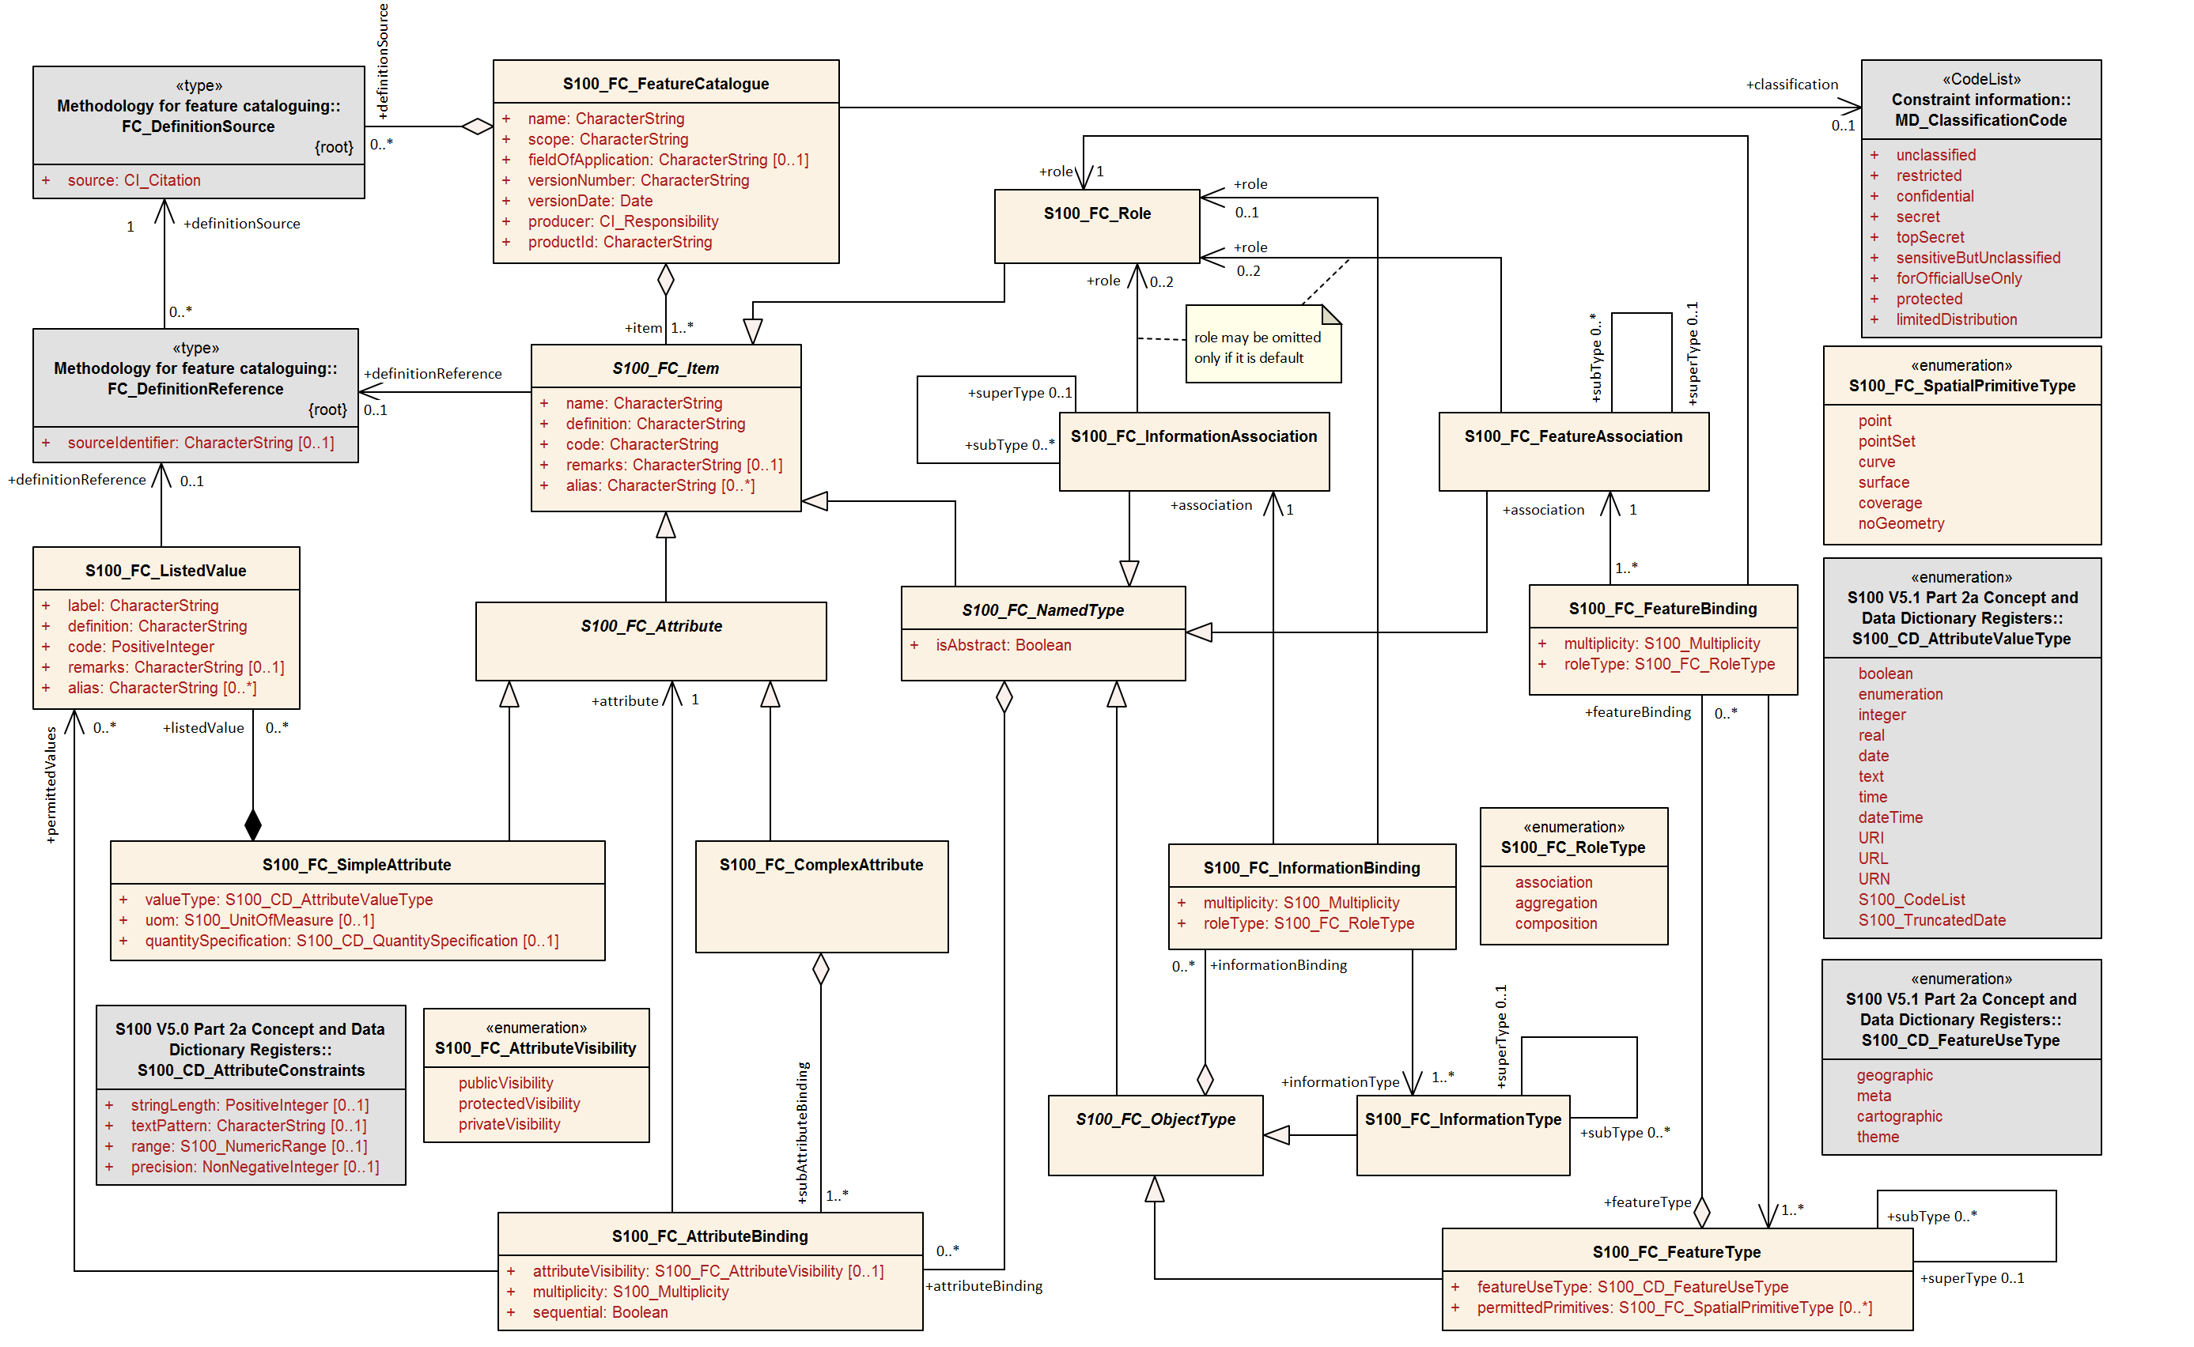
Figure 5-A-1. Feature Catalogue — UML Model
Table 5-A-1 — S100_FC_FeatureCatalogue
Role Name | Name | Description | Mult | Type | Remarks
Class | S100_FC_FeatureCatalogue | A Feature Catalogue contains its identification and contact information, and definition of some number of feature types with other information necessary for those definitions | - | - | -
Attribute | name | Name for this Feature Catalogue | 1 | CharacterString
Attribute | scope | Subject domain of feature types defined in this Feature Catalogue | 1 | CharacterString
Attribute | fieldOfApplication | Description of the kind of use to which this Feature Catalogue may be put | 0..1 | CharacterString
Attribute | versionNumber | Version number of this Feature Catalogue, which may include both a major version number or letter and a sequence of minor release numbers or letters, such as “3.2.4a.” The format of this attribute may differ between cataloguing authorities | 1 | CharacterString
Attribute | versionDate | Effective date of this Feature Catalogue | 1 | Date
Attribute | productId | The ID of the product for which the Catalogue is intended | 1 | CharacterString
Attribute | producer | Name, address, country, and telecommunications address of person or organization having primary responsibility for the intellectual content of this Feature Catalogue | 1 | CI_Responsibility | CI_Responsibility>CI_Individual or  CI_Responsibility>CI_Organisation
Role | item | List of items defined by this Feature Catalogue; items are feature types, information types, feature associations, information associations, attributes, and roles | 1..* | S100_FC_Item | Aggregation
Role | definitionSource | List of sources of definitions of items and listed values that are defined by this Feature Catalogue. Usually those sources are Feature Data Dictionaries | 0..* | FC_DefinitionSource | Aggregation
Role | classification | The classification of the Feature Catalogue. | 0..1 | MD_ClassificationCode | 1 unclassified  2 restricted  3 confidential  4 secret  5 top secret  6 sensitive but unclassified  7 for official use only  8 protected  9 limited distribution

Table 5-A-2 — FC_DefinitionSource
Role Name | Name | Description | Mult | Type | Remarks
Class | FC_DefinitionSource | Class that specifies the source of a definition | - | - | -
Attribute | source | Actual citation of the source, sufficient to identify the document and how to obtain it | 1 | CI_Citation

Table 5-A-3 — FC_DefinitionReference
Role Name | Name | Description | Mult | Type | Remarks
Class | FC_DefinitionReference | Class that links a data instance to the source of its definition | - | - | -
Attribute | sourceIdentifier | Information to locate the definition in the source document. The format of this information is specific to the structure of the source document | 1 | CharacterString | Includes online dictionaries or “vocabularies” used by dictionary-type codelist attributes
Role | definitionSource | The source of the definition | 1 | FC_DefinitionSource

Table 5-A-4 — S100_FC_Item
Role Name | Name | Description | Mult | Type | Remarks
Class | S100_FC_Item | Abstract base class that defines the common properties of all items in the Feature Catalogue; items are feature types, information types, feature associations, information associations, attributes and roles | - | - | Abstract class
Attribute | name | Name of the item | 1 | CharacterString
Attribute | definition | Definition of the named type in a natural language | 1 | CharacterString
Attribute | code | Code that uniquely identifies the named type within the Feature Catalogue | 1 | CharacterString
Attribute | remarks | Further explanation about the item | 0..1 | CharacterString
Attribute | alias | Equivalent name(s) of this item | 0..* | CharacterString
Role | definitionReference | The link to the source of the definition | 0..1 | FC_DefinitionReference

Table 5-A-5 — S100_FC_NamedType
Role Name | Name | Description | Mult | Type | Remarks
Class | S100_FC_NamedType | Abstract base class that defines the common properties for feature types and information types | - | - | Abstract class
Attribute | isAbstract | Indicates if instances of this named type can exist in a geographic data set. Abstract types cannot be instantiated but serve as base classes for other (non-abstract) types | 1 | Boolean
Role | attributeBinding | List of bindings to attributes which describe the characteristic of this named type | 0..* | S100_FC_AttributeBinding | Aggregation

Table 5-A-6 — S100_FC_ObjectType
Role Name | Name | Description | Mult | Type | Remarks
Class | S100_FC_ObjectType | Abstract base class that defines the common properties for feature types and information types | - | - | Abstract class; derived from S100_FC_NamedType
Role | informationBinding | List of bindings to information types that can be associated to this object type by means of an information association | 0..* | S100_FC_InformationBinding | Aggregation

Table 5-A-7 — S100_FC_InformationType
Role Name | Name | Description | Mult | Type | Remarks
Class | S100_FC_InformationType | Class that defines all properties of an information type | - | - | Derived from S100_FC_NamedType
Role | superType | Indicates the information type from which an information type is derived. The sub-type will inherit all properties from its super-type: Name, definition and code will usually be overridden by the sub-type, although new properties may be added to the sub-type | 0..1 | S100_FC_InformationType
Role | subType | Indicates the information types which are derived from an information type | 0..* | S100_FC_InformationType

Table 5-A-8 — S100_FC_FeatureType
Role Name | Name | Description | Mult | Type | Remarks
Class | S100_FC_FeatureType | Class that defines all properties of a feature type | - | - | Derived from S100_FC_NamedType
Attribute | featureUseType | The use type of this feature type | 1 | S100_CD_FeatureUseType
Attribute | permittedPrimitives | The combination of 0 or more spatial primitives permitted for feature type | 0..* | S100_FC_SpatialPrimitiveType
Role | featureBinding | List of bindings to feature types that can be related to this feature type by means of a feature association | 0..* | S100_FC_FeatureBinding | Aggregation
Role | superType | Indicates the feature type from which a feature type is derived. The sub-type will inherit all properties from its super-type: Name, definition and code will usually be overridden by the sub-type, although new properties may be added to the sub-type  If permittedPrimitives is present in a sub-type it overrides permittedPrimitives in any of its super-types | 0..1 | S100_FC_FeatureType
Role | subType | Indicates the feature types which are derived from a feature type | 0..* | S100_FC_ FeatureType

Example: If a super-type allows point and area primitives and the sub-type only curve primitives, instances of the sub-type must indicate location with curve spatial objects. Sub-types of the sub-type will take only line primitives unless they specify their own permitted primitives.
Table 5-A-9 — S100_FC_InformationAssociation
Role Name | Name | Description | Mult | Type | Remarks
Class | S100_FC_InformationAssociation | An information association describes the relationship between an object (feature or information type) and an information type | - | - | Derived from S100_FC_NamedType Individual Product Specifications may restrict directionality
Role | role | The role of the association | 0..2 | S100_FC_Role | Default role name if missing  Product Specification can constrain further
Role | superType | Indicates the information association from which an information association is derived. The sub-type will inherit all properties from its super-type: Name, definition and code will usually be overridden by the sub-type, although new properties may be added to the sub-type | 0..1 | S100_FC_InformationAssociation
Role | subType | Indicates the information associations which are derived from an information association | 0..* | S100_FC_InformationAssociation

Table 5-A-10 — S100_FC_FeatureAssociation
Role Name | Name | Description | Mult | Type | Remarks
Class | S100_FC_FeatureAssociation | A feature association describes the relationship between two feature types  A feature association is bidirectional and has a separate role for each direction | - | -
Role | role | The role of the association | 0..2 | S100_FC_Role
Role | superType | Indicates the feature association from which a feature association is derived. The sub-type will inherit all properties from its super-type: Name, definition and code will usually be overridden by the sub-type, although new properties may be added to the sub-type | 0..1 | S100_FC_FeatureAssociation
Role | subType | Indicates the feature associations which are derived from a feature association. | 0..* | S100_FC_FeatureAssociation
Table 5-A-11 — S100_FC_Role
Role Name | Name | Description | Mult | Type | Remarks
Class | S100_FC_Role | A role which can be used in a feature association or an information association | - | - | Derived from S100_FC_Item

Table 5-A-12 — S100_FC_Attribute
Role Name | Name | Description | Mult | Type | Remarks
Class | S100_FC_Attribute | Abstract base class for the two kinds of attributes: simple attributes and complex attributes. Attributes carry the characteristics of named types | - | - | Abstract derived from S100_FC_Item

Table 5-A-13 — S100_FC_SimpleAttribute
Role Name | Name | Description | Mult | Type | Remarks
Class | S100_FC_SimpleAttribute | Attribute that carries a value | - | - | Derived from S100_FC_Attribute
Attribute | valueType | The value type of this feature attribute | 1 | S100_CD_AttributeValueType
Attribute | uom | Unit of measure used for values of this feature attribute | 0..1 | S100_UnitOfMeasure
Attribute | quantitySpecification | Specification of the quantity | 0..1 | S100_CD_QuantitySpecification
Role | constraints | Constraints which may apply to the attribute | 0..1 | S100_CD_AttributeConstraints | Composition
Role | listedValue | Set of listed values for an enumerated attribute domain | 0..* | S100_FC_ListedValue | Composition.  Applies only if valueType is Enumeration or S100_Codelist (with codelistType=open enumeration)
Table 5-A-14 — S100_FC_ComplexAttribute
Role Name | Name | Description | Mult | Type | Remarks
Class | S100_FC_ComplexAttribute | A complex attribute consists of a list of sub-attributes which can be both simple and complex attributes | - | - | Derived from S100_FC_Attribute
Role | subAttributeBinding | List of attribute bindings to the sub-attributes | 1..* | S100_FC_AttributeBinding | Aggregation
Table 5-A-15 — S100_FC_ListedValue
Role Name | Name | Description | Mult | Type | Remarks
Class | S100_FC_ListedValue | Value of an enumerated attribute domain, including its codes and definition | - | -
Attribute | label | Descriptive label that uniquely identifies one value of the feature attribute | 1 | CharacterString
Attribute | definition | Definition of the listed value in a natural language | 1 | CharacterString
Attribute | code | Numeric code that uniquely identifies the listed value for the corresponding feature attribute | 1 | PositiveInteger
Attribute | remarks | Further explanation about the listed value | 0..1 | CharacterString
Attribute | alias | Equivalent name(s) of this listed value | 0..* | CharacterString
Role | definitionReference | The link to the source of the definition | 0..1 | FC_DefinitionReference

Table 5-A-16— S100_FC_AttributeBinding
Role Name | Name | Description | Mult | Type | Remarks
Class | S100_FC_AttributeBinding | Class that is used to describe the specifics of how an attribute is bound to a particular named type or a complex attribute | - | -
Attribute | multiplicity | Multiplicity defining how many instances of the attribute can be part of the named type or complex attribute | 1 | S100_Multiplicity
Attribute | sequential | Describes if the sequence of the attributes is meaningful or not | 1 | Boolean | Applies only to attributes which may occur more than once
Attribute | attributeVisibility | An indication of the expected visibility of an attribute in end user systems | 0..1 | S100_FC_AttributeVisibility
Role | permittedValues | Permissible values of the attribute | 0..* | S100_FC_ListedValue | Applies only to attributes of data type enumeration
Role | attribute | The attribute that is bound to the item or complex attribute | 1 | S100_FC_Attribute

Table 5-A-17 — S100_FC_InformationBinding
Role Name | Name | Description | Mult | Type | Remarks
Class | S100_FC_InformationBinding | Class describing the use of an information type by a named type | - | -
Attribute | multiplicity | Multiplicity defining how many instances of the target information type can be linked to one instance of the named type | 1 | S100_Multiplicity
Attribute | roleType | The nature of the association end | 1 | S100_FC_RoleType
Role | role | The role used for the binding. It must be part of the association used for the binding and defines the end of the association | 0..1 | S100_FC_Role
Role | association | The association used for the binding; defining also the role | 1 | S100_FC_InformationAssociation
Role | informationType | The target information type | 1..* | S100_FC_InformationType

Table 5-A-18 — S100_FC_FeatureBinding
Role Name | Name | Description | Mult | Type | Remarks
Class | S100_FC_FeatureBinding | Class describing the relationship from one feature type to another feature type by means of a feature association | - | -
Attribute | multiplicity | Multiplicity defining how many instances of the target feature type can be linked to one instance of the source feature type | 1 | S100_Multiplicity
Attribute | roleType | The nature of the association end | 1 | S100_FC_RoleType
Role | featureType | The target feature type | 1..* | S100_FC_FeatureType
Role | role | The role used for the binding. It must be part of the association used for the binding and defines the end of the association | 1 | S100_FC_Role
Role | association | The association used for the binding | 1 | S100_FC_FeatureAssociation

Table 5-A-19 — S100_FC_RoleType
Item | Name | Description | Remarks
Enumeration | S100_FC_RoleType | Defines the type of an association end (that is, a “role”)
Literal | association | The association end is an ordinary linkage. (In UML terms, the role type is “aggregationKind=ordinary” and the link in a diagram does not have a diamond) | The object at this end may be participating in an ordinary association, an aggregation, or a composition
Literal | aggregation | The association end is a UML aggregation. (In UML terms, the role type is “aggregationKind=aggregation” and the link in a diagram has an unfilled diamond at this association end) | The object at this end is the “owner”, “whole” or “container” in an aggregation association
Literal | composition | The association end is a UML aggregation. (In UML terms, the role type is “aggregationKind=composition” and the link in a diagram has a filled diamond at this association end) | The object at this end is the “owner”, “whole” or “container” in an composition association

NOTE: If one end of the association is “aggregation” or “composition”, the other end must be coded as “association”.
Table 5-A-20 — S100_FC_SpatialPrimitiveType
Item | Name | Description | Remarks
Enumeration | S100_FC_SpatialPrimitiveType | Specifies spatial primitives permitted for use with a feature instance
Literal | point | Point spatial primitive | GM_Point
Literal | pointSet | Point set spatial primitive | GM_MultiPoint
Literal | curve | Curve spatial primitive | GM_OrientableCurve
Literal | surface | Surface spatial primitive | GM_OrientableSurface
Literal | coverage | Coverage spatial primitive | CV_Coverage
Literal | noGeometry | The feature type is not associated with a spatial primitive for the location of instances | In some cases, an explicit statement is needed to indicate that there are no spatial primitives for the locations of instances. See the rules for subtypes and super-types in S100_FC_FeatureType

Table 5-A-21 — S100_FC_ AttributeVisibility
Item | Name | Description | Remarks
Enumeration | S100_FC_AttributeVisibility | An indication of the expected visibility of an attribute in end user systems | Production systems should be considered as distinct from end user systems and may not restrict attribute visibility in the same way as end user systems
Literal | publicVisibility | Attribute visibility is for all uses
Literal | protectedVisibility | Attribute visibility is protected in some uses. The details to be defined in the product specification
Literal | privateVisibility | Attribute visibility is private and should not be shown outside production environments. The details to be defined in the product specification

Page intentionally left blank

